#### 

#### **Multi Branch Setup**

#### **Create a Jenkinsfile in the master Branch**

Jenkinsfile in the master branch:

pipeline {

agent any

stages {

stage('Build') {

steps {

echo 'Building...'

// Add your build steps here

}

}

stage('Test') {

steps {

echo 'Testing...'

// Add your test steps here

}

}

stage('Deploy') {

steps {

echo 'Deploying...'

// Add your deploy steps here

}

}

}

}

#### **3. Configure a Multibranch Pipeline Job in Jenkins**

1. **Go to Jenkins Dashboard**: Click on New Item.
2. **Create Multibranch Pipeline**: Enter a name for the job, select Multibranch Pipeline, and click OK.
3. **Branch Sources**: Add your Git repository URL under Branch Sources.
4. **Script Path**: Under Build Configuration, set the Script Path to Jenkinsfile.

### **Best Practices for Jenkinsfile**

### **Use Declarative Pipeline Syntax**

**Description:** The declarative pipeline syntax is more readable and provides a more structured way to define Jenkins pipelines.

**Use Case:**

* **Consistent Structure:** By using declarative syntax, teams can maintain a consistent structure across all Jenkinsfiles, making them easier to read and understand.

**Example:**  
pipeline {

agent any

stages {

stage('Build') {

steps {

echo 'Building...'

// Add build steps here

}

}

stage('Test') {

steps {

echo 'Testing...'

// Add test steps here

}

}

stage('Deploy') {

steps {

echo 'Deploying...'

// Add deploy steps here

}

}

}

}

### **2. Use Descriptive Stage and Step Names**

**Description:** Clearly name your stages and steps to describe their purpose. This makes the pipeline easier to understand at a glance.

**Use Case:**

* **Improved Readability:** When others view the Jenkinsfile or the pipeline logs, they can quickly understand what each part of the pipeline is doing.

**Example:**  
pipeline {

agent any

stages {

stage('Compile Code') {

steps {

echo 'Compiling the source code...'

// Compilation steps

}

}

stage('Run Unit Tests') {

steps {

echo 'Executing unit tests...'

// Unit test steps

}

}

stage('Deploy to Production') {

steps {

echo 'Deploying the application to production...'

// Deployment steps

}

}

}

}

### **3. Use Environment Variables**

**Description:** Define environment variables in your Jenkinsfile for values that may change or are reused multiple times.

**Use Case:**

* **Centralized Configuration:** Environment variables allow for centralized configuration, making it easier to update values without modifying multiple steps.

**Example:**  
pipeline {

agent any

environment {

JAVA_HOME = '/usr/lib/jvm/java-11-openjdk'

APP_ENV = 'production'

}

stages {

stage('Setup') {

steps {

echo "Using Java from ${env.JAVA_HOME}"

echo "Deploying to ${env.APP_ENV} environment"

}

}

// Additional stages

}

}

### **4. Use Shared Libraries**

**Description:** Move common code and functions into shared libraries to promote reuse and avoid duplication.

**Use Case:**

* **Code Reusability:** Shared libraries can be used to define common functions like deployment scripts or testing steps, which can be reused across multiple Jenkinsfiles.
* **Example:**

**Library (vars/common.groovy):**  
def deployApp(env) {

echo "Deploying to ${env} environment"

// Deployment logic

}

**Jenkinsfile:**  
@Library('common-library') _

pipeline {

agent any

stages {

stage('Deploy') {

steps {

script {

deployApp('production')

}

}

}

}

}

### **5. Use Input Step for Manual Approval**

**Description:** Use the input step to require manual approval for critical stages like deploying to production.

**Use Case:**

* **Controlled Deployments:** Ensure that sensitive operations like production deployments require explicit approval from a responsible person.

**Example:**  
pipeline {

agent any

stages {

stage('Deploy to Production') {

steps {

script {

input message: 'Approve deployment to production?', ok: 'Deploy'

echo 'Deploying to production...'

// Deployment steps

}

}

}

}

}

### **6. Use Post Actions for Cleanup and Notifications**

**Description:** Define post actions to handle notifications, cleanup, or other steps that should occur regardless of the pipeline result.

**Use Case:**

* **Consistent Cleanup:** Ensure that temporary files or resources are cleaned up and notifications are sent regardless of whether the build succeeded or failed.

**Example:**  
pipeline {

agent any

stages {

stage('Build') {

steps {

echo 'Building...'

// Build steps

}

}

}

post {

success {

echo 'Build succeeded!'

// Notification or other success steps

}

failure {

echo 'Build failed!'

// Notification or other failure steps

}

always {

echo 'Cleaning up...'

// Cleanup steps

}

}

}

### **7. Use Parameterized Pipelines**

**Description:** Define parameters in your Jenkinsfile to make the pipeline more flexible and configurable.

**Use Case:**

* **Dynamic Pipelines:** Allow different configurations or environments to be selected at runtime without modifying the Jenkinsfile.

**Example:**  
pipeline {

agent any

parameters {

string(name: 'BRANCH_NAME', defaultValue: 'main', description: 'Branch to build')

choice(name: 'DEPLOY_ENV', choices: ['dev', 'staging', 'production'], description: 'Deployment environment')

}

stages {

stage('Checkout') {

steps {

git branch: params.BRANCH_NAME, url: 'https://github.com/example/repo.git'

}

}

stage('Deploy') {

steps {

echo "Deploying to ${params.DEPLOY_ENV} environment"

// Deployment steps

}

}

}

}

### **8. Utilize Stash and Unstash for Artifact Management**

**Description:** Use stash and unstash to share files between stages in the pipeline.

**Use Case:**

* **Artifact Management:** Pass build artifacts between stages without redoing the same work or relying on a shared workspace.

**Example:**  
pipeline {

agent any

stages {

stage('Build') {

steps {

script {

// Build steps

stash includes: 'target/*.jar', name: 'app-jar'

}

}

}

stage('Test') {

steps {

script {

unstash 'app-jar'

// Test steps using the stashed jar

}

}

}

stage('Deploy') {

steps {

script {

unstash 'app-jar'

// Deploy steps using the stashed jar

}

}

}

}

}

### **9. Leverage Parallel Execution**

**Description:** Use the parallel step to run multiple tasks concurrently, reducing the overall build time.

**Use Case:**

* **Efficiency:** Speed up the pipeline by running independent tasks simultaneously, such as different test suites.

**Example:**  
pipeline {

agent any

stages {

stage('Build') {

steps {

echo 'Building...'

// Build steps

}

}

stage('Test') {

parallel {

stage('Unit Tests') {

steps {

echo 'Running unit tests...'

// Unit test steps

}

}

stage('Integration Tests') {

steps {

echo 'Running integration tests...'

// Integration test steps

}

}

}

}

}

}

### **10. Ensure Proper Error Handling**

**Description:** Use try-catch blocks within script steps to handle errors gracefully and ensure that proper cleanup or notifications occur.

**Use Case:**

* **Resilience:** Make the pipeline more robust by handling unexpected errors and providing meaningful feedback.

**Example:**  
pipeline {

agent any

stages {

stage('Build') {

steps {

script {

try {

// Build steps that might fail

echo 'Building...'

} catch (Exception e) {

echo "Build failed: ${e.message}"

currentBuild.result = 'FAILURE'

}

}

}

}

}

* }

### **Distributing The Builds**

### **Configure the Slave Machine for Use with the Jenkins Master**

* Open the /etc/passwd file:

[root@master]$ vim /etc/passwd

* In the last line in the file (beginning with jenkins), change /bin/false to /bin/bash to allow the jenkins user a shell login.
* Save and exit the file by pressing Escape followed by :x.
* Change the password for the jenkins user:

[root@master]$ passwd jenkins

* Enter a password of your choice that you'll easily remember.
* Switch to jenkins:

[root@master]$ su jenkins

* Change directory:

[jenkins@master]$ cd ~

* Generate a public/private RSA key pair:

[jenkins@master]$ ssh-keygen

* Log in to the slave server:

[jenkins@master]$ ssh cloud_user@<SLAVE_PUBLIC_IP_ADDRESS>

* Become root:

[cloud_user@slave]$ sudo su

* Create a jenkins user:

[root@slave]$ useradd jenkins

* Create a password:

[root@slave]$ passwd jenkins

* Open the sudoers file:

[root@slave]$ visudo

* In the Defaults section, beneath root, add:

#Here #Jenkins is the username

jenkins ALL=(ALL) NOPASSWD: ALL

* Save and exit the file by pressing Escape followed by :x.
* Exit root:

[root@slave]$ exit

* See who you're logged in as:

[cloud_user@slave]$ whoami

* You should see you're cloud_user.
* Switch to jenkins:

[cloud_user@slave]$ su jenkins

* Enter the password you created.
* Change directory:

[jenkins@slave]$ cd ~

* Enter exit twice to exit back to the master server.
* See who you're signed in as:

whoami

* You should see you're jenkins.
* As the jenkins user on the master server, copy the jenkins user's ssh keys to the slave server:

[jenkins@master]$ ssh-copy-id jenkins@<SLAVE_PUBLIC_IP_ADDRESS>

* Run the following:

cat ./.ssh/id_rsa

* Keep the output listed, as we'll need it for a later step.

### Run the Maven Build on the Remote Agent

* In a new browser tab, navigate to http://<JENKINS_MASTER_SERVER_PUBLIC_IP>:8080.
* Click Manage Jenkins in the left-hand menu.
* Click Nodes.
* Click New Node.
* Give it a name of slave1.
* Select Permanent Agent.
* Click Create.
* For Remote root directory, enter /home/jenkins.
* For Labels, enter slave1.
* For Host, enter the slave server's public IP address.
* Next to Credentials, click Add > Jenkins.
* Set the following values:
  + Kind: SSH Username with private key
  + Username: jenkins
  + Private Key: Enter directly
    - Copy the entire RSA key in the terminal (from dashes to dashes) and paste it into the Key window
  + ID: jkey
  + Description: jenkinsuser
* Click Add.
* Set Credentials to jenkins (jenkinsuser).
* Click Save.
* In the upper-left corner, click Jenkins > New Item.
* Enter an item name of mavenproject.
* Select Freestyle project.
* Click OK.
* Set the following values:
  + General
    - Restrict where this project can be run: Check
    - Label Expression: slave1
  + Source Code Management
    - Git: Check
    - Repository URL: https://github.com/nkheria/content-cje-prebuild.git
      * Click outside the box to make sure the red text goes away.
  + Build
    - Click Add build step > Invoke top-level Maven targets.
      * Goals: clean package
    - Click Add build step > Execute shell.
      * Command: bin/makeindex
  + Post-build Actions
    - Click Add post-build action > Archive the artifacts.
      * Files to archive: index.jsp
    - Click Advanced....
      * Fingerprint all archived artifacts: Check
      * Leave other default boxes checked.
* Click Save.
* In the upper-left corner, click Jenkins > Manage Jenkins > Global Tool Configuration.
* In the Maven section, click Add Maven.
* Give it the name M3.
* Click Save.
* In the upper-left corner, click Jenkins.
* Click mavenproject.
* Click Configure in the left-hand menu.
* In the Build section, set Maven Version to M3.
* Click Save.
* Click Build Now in the left-hand menu.

**Project 01**

#### **Problem Statement:**

You are tasked with setting up a CI/CD pipeline using Jenkins to streamline the deployment process of a simple Java application. The pipeline should accomplish the following tasks:

1. **Fetch the Dockerfile**: The pipeline should clone a GitHub repository containing the source code of the Java application and a Dockerfile.
2. **Create a Docker Image**: The pipeline should build a Docker image from the fetched Dockerfile.
3. **Push the Docker Image**: The pipeline should push the created Docker image to a specified DockerHub repository.
4. **Deploy the Container**: The pipeline should deploy a container using the pushed Docker image.

#### **Deliverables:**

1. **GitHub Repository**: A GitHub repository containing:
   * The source code of a simple Java application.

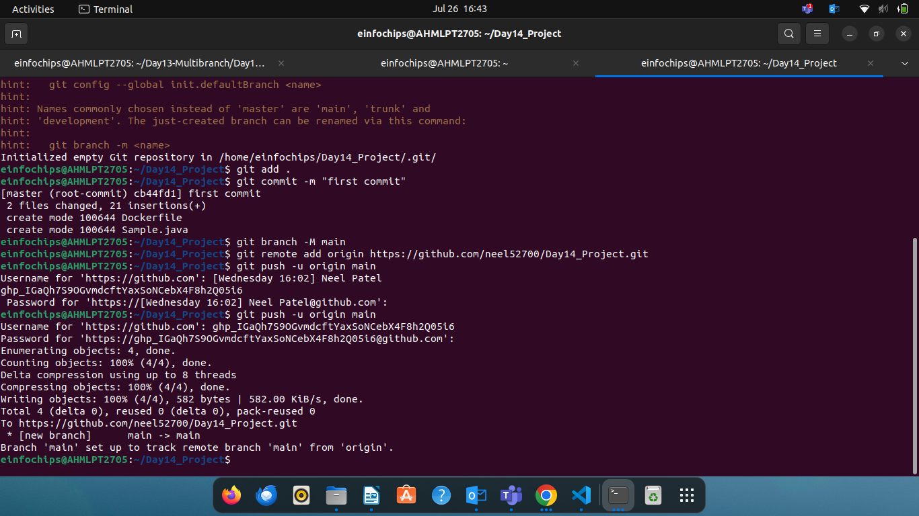

* + A Dockerfile for building the Docker image.

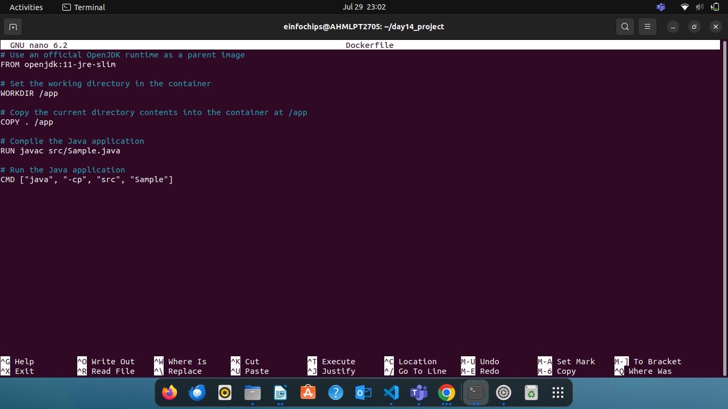

1. **Jenkins Pipeline Script**: A Jenkinsfile (pipeline script) that:
   * Clones the GitHub repository.
   * Builds the Docker image.
   * Pushes the Docker image to DockerHub.
   * Deploys a container using the pushed image.

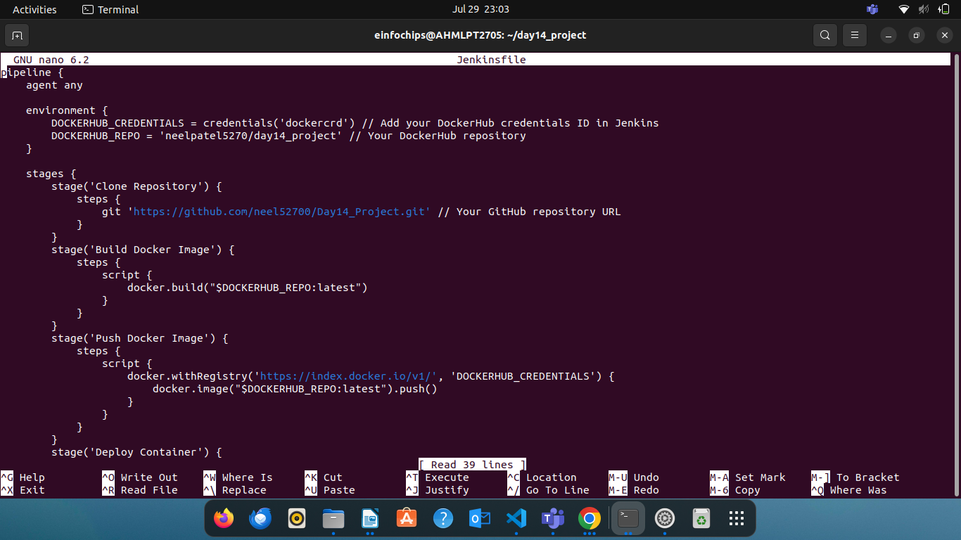

1. **DockerHub Repository**: A DockerHub repository where the Docker images will be stored.

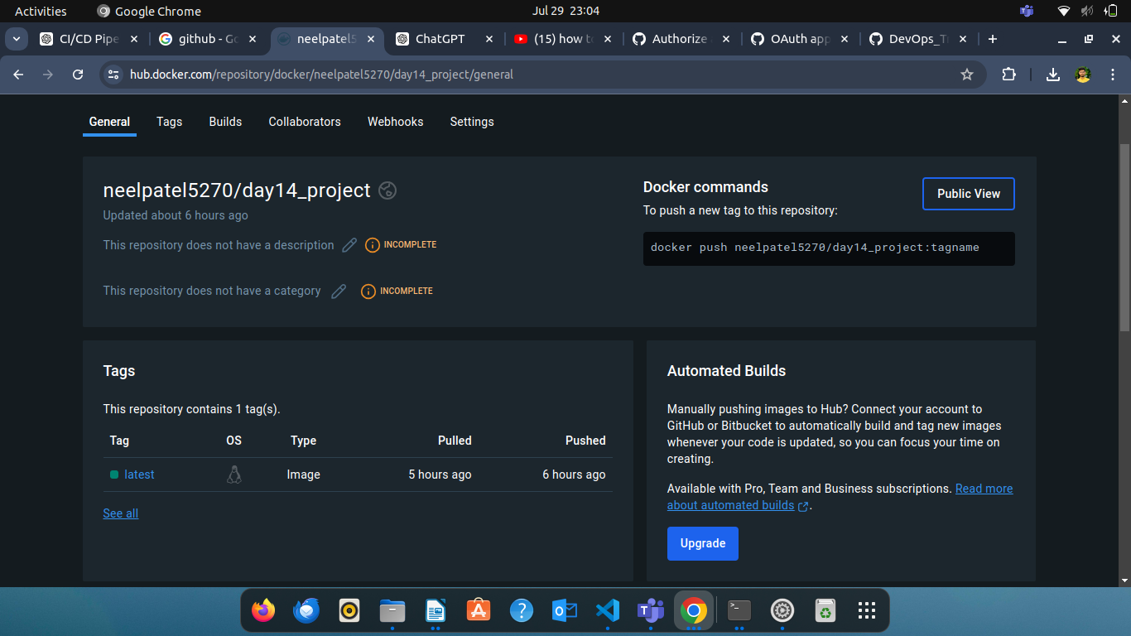

1. **Jenkins Setup**:
   * Jenkins installed and configured on a local Ubuntu machine.
   * Required plugins installed (e.g., Git, Docker, Pipeline).

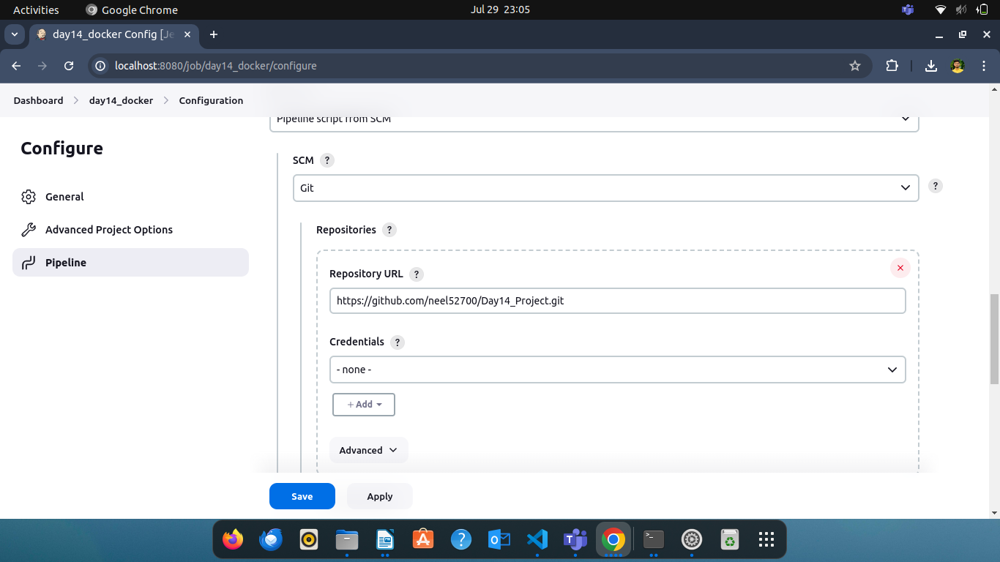

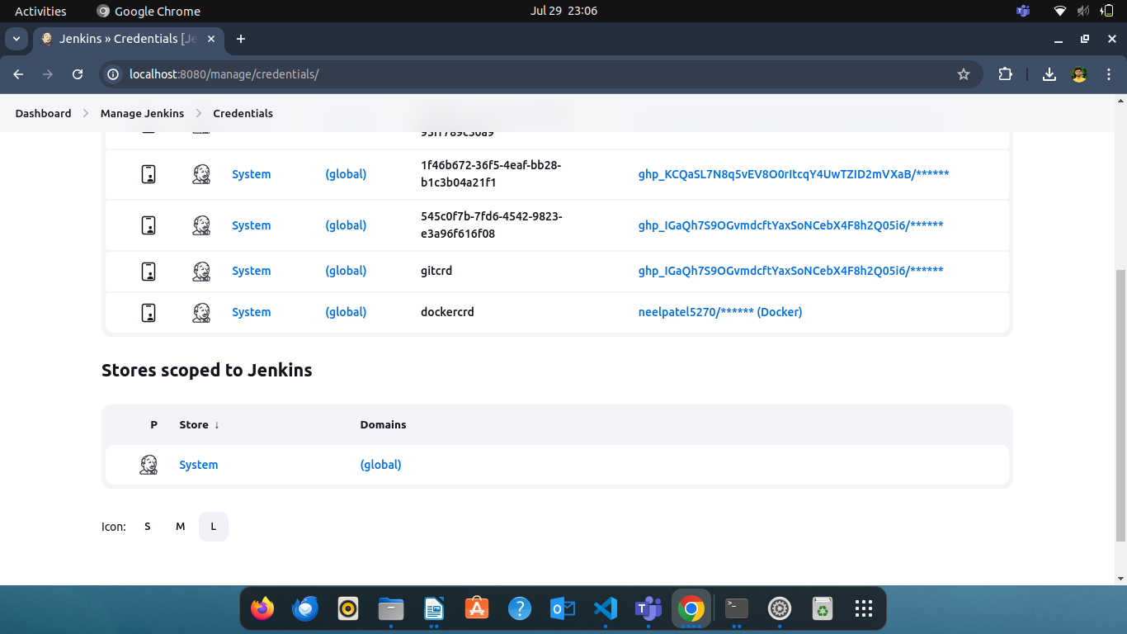

1. **Documentation**: Detailed documentation explaining:
   * How to set up the local Jenkins environment.
   * Configuration steps for the pipeline.
   * Instructions for verifying the deployment.

